Name of the Module: **Introduction to Engineering**

Type of activity: **Individual**

Name of the Faculty: Prof. Sachidananda T G

**1. Paste the photo in the given space. Photo should clearly indicate the identified problem**

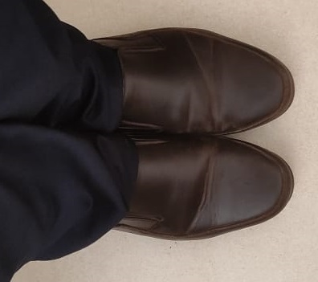

2. Describe the problem

Automatic Polishing of Shoes without any human intervention

3. Describe the proposed solution to the identified problem

Built Mechanism will apply the prepared Shoe Polish Solution on shoe with the help of electrical actuators. The working of mechanism will be programmed and automated using Arduino.

4. Mention which all disciplines of engineering get involved to provide the proposed solution.

Mechanical Engineering to build a mechanism to polish shoes.

Electrical Engineering to select motor for working of mechanism.

Chemical Engineering to create Shoe Polish solution.

Electronics Engineering for automation.